Table 3. Descriptive statistics and results from the test and mean differences by gender.
 | DNA | Husbands | Wives | Paired t-test
Variable description | [1] | [2] | [3] | [1]-[2] | [1]-[3] | [2]-[3]
Dependent variables.
Y/N ICV
All observations | 0.645 | 0.621 | 0.582 | 0.977 | 2.598*** | 2.224**
Zone 1 | 0.597 | 0.640 | 0.656 | -0.905 | -1.209 | -0.419
Zone 2 | 0.693 | 0.697 | 0.597 | -0.094 | 2.142** | 2.755***
Zone 3 | 0.503 | 0.370 | 0.358 | 2.639*** | 2.810*** | 0.470
Zone 4 | 0.793 | 0.764 | 0.721 | 0.631 | 1.590 | 1.227
Independent variables
Managed plots
Husband Managed |  | 0.978 | 0.621 |  |  | 6.026***
Wife Managed |  | 0.095 | 0.276 |  |  | -5.875***
Joint Managed |  | 1.414 | 1.656 |  |  | -3.276***
Membership of a coop
Household |  | 0.262 | 0.296 |  |  | -1.699*
Husband Only |  | 0.067 | 0.091 |  |  | -1.847*
Wife Only |  | 0.016 | 0.029 |  |  | -1.734*
Joint Coop |  | 0.176 | 0.178 |  |  | -0.147
Credit Access
Household |  | 0.451 | 0.379 |  |  | 3.193***
Husband Only |  | 0.112 | 0.043 |  |  | 5.163***
Wife Only |  | 0.018 | 0.033 |  |  | -1.862*
Joint Credit |  | 0.321 | 0.303 |  |  | 0.804
Extension Access
Household |  | 0.444 | 0.287 |  |  | 7.314***
Husband Only |  | 0.222 | 0.125 |  |  | 5.317***
Wife Only |  | 0.007 | 0.008 |  |  | -0.378
Joint Credit |  | 0.204 | 0.108 |  |  | 6.152
Consumption of ICV (%) |  | 34.756 | 33.779 |  |  | 1.280
Household attributes
Age |  | 50.543 | 40.435 |  |  | 28.879***
Education |  | 9.342 | 8.029 |  |  | 6.858***
Main occupation |  | 1.148 | 2.045 |  |  | -7.259***
Contribution to farm work (%) |  | 80.206 | 70.089 |  |  | 8.646***
Men In House |  | 2.314 | 2.1 |  |  | 4.918***
Women In House |  | 2.23 | 2.169 |  |  | 1.491
Kids |  | 2.763 | 2.599 |  |  | 2.135**

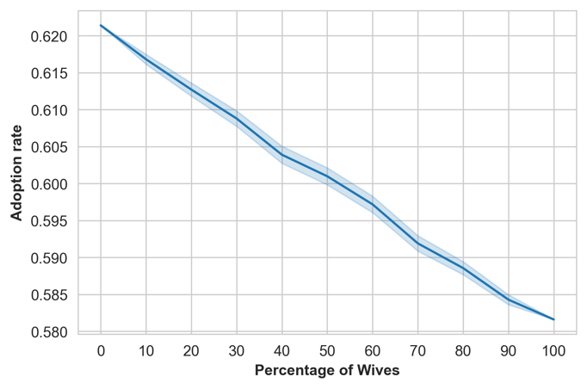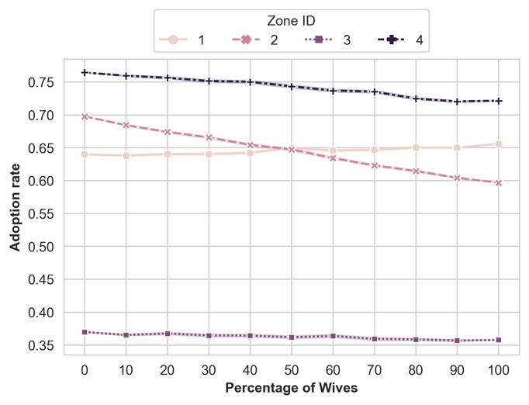
Figure 1. The self-reported ICV adoption Panel depicts the Monte Carlo simulation of 500 iterations of each percentage for adoption rate about wife respondent percentage. Panel b disaggregates the same data and the same simulation by Zone IDs.

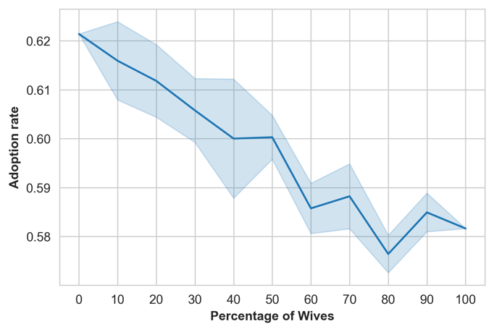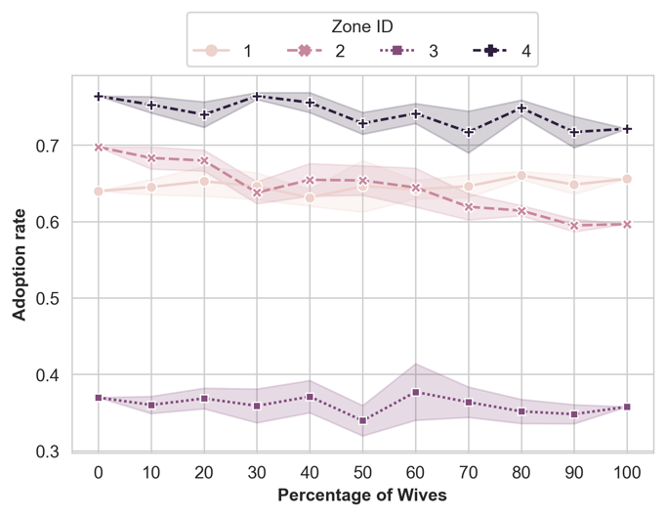
Figure 2. The self-reported ICV adoption. Panel a depicts the Monte Carlo simulation of 5 iterations of each percentage for adoption rate in relation to female respondent percentage. Panel b disaggregates the same data and the same simulation by Zone IDs.

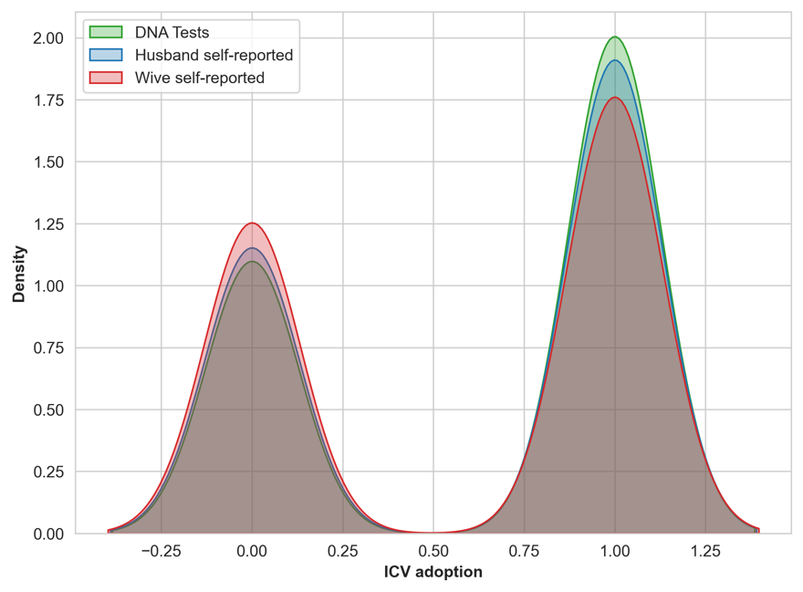

Figure 3. The self-reported ICV adoption by husbands and wives compared to the DNA fingerprinting data.

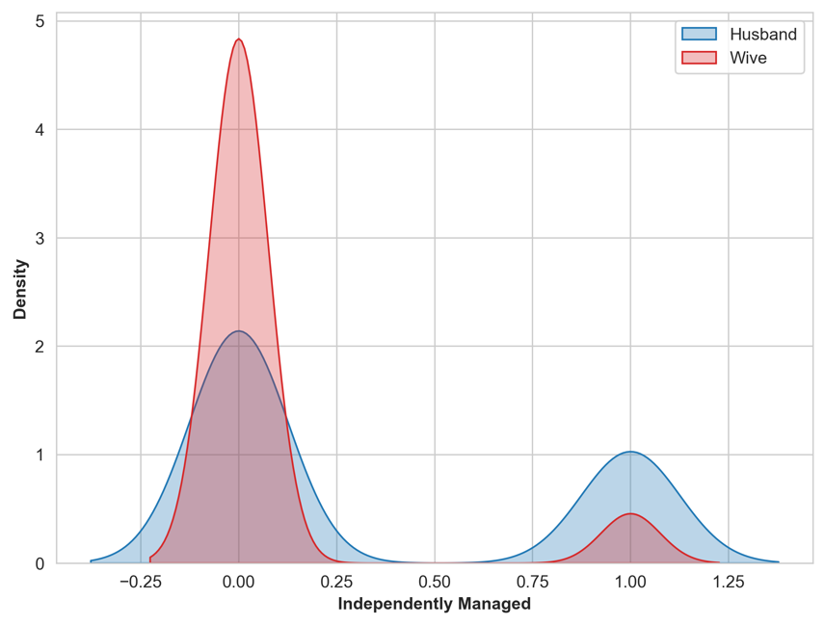

Figure 3. The comparison of the self-reported ICV adoption managed by husbands and wives.

